**252: Life Expectancy Analytics**

Your submissions:

* Report_252.pdf
* R Codes_252.txt
* R Outputs_252.pdf

Notes

* The deadline is in the noon, not midnight
* No extension to the deadline
* Follow the given template
* Each team can only submit one copy by a single member, just list all of your members in the report

|  |  |  |  |
| --- | --- | --- | --- |
| First Name | Last Name | Email (hawk.iit.edu) | Student ID |
| Minguk | Kim | mkim105@hawk.iit.edu | A20437179 |
| Boyun | Jang | bjang7@hawk.iit.edu | A20437298 |

Table of Contents

**1. Introduction** 2

**2. Data** 2

**3. Problems to be Solved** 2

**4. Solutions** 2

**5. Experiments and Results** 2

5.1. Methods and Process 2

5.2. Evaluations and Results 2

5.3. Findings 2

**6. Conclusions and Future Work** 2

6.1. Conclusions 2

6.2. Limitations 2

6.3. Potential Improvements or Future Work 2

# **Introduction**

Life expectancy is one of the factors that measure human development index (HDI) in each country besides human education level and living standard. It is used to describe the quality of life in a particular area. The difference in life expectancy is also cited to demonstrate the need for medical care and the improvement of social support.

In order to prove the necessity of medical and social support for each country, we are going to analyze the factors of life expectancy such as the national mortality rate, economic factors, social factors and other health-related factors.

We will present what kind of improvements are needed to improve the life expectancy of the population by predicting the vulnerable diseases and environments that affect the mortality rate in a specific area in order to improve the mortality rate.

For the result, our main goal is find the factors which are needed to improve the life expectancy.

# **2. Data**

Data sets related to life expectancy and health factors in 193 countries were collected from the same WHO data store website. Economic data was collected on the UN website. Only representative elements were selected from all categories of health-related factors. The data set consists of 22 columns and 2938 rows, which means 20 prediction variables.

|  |  |  |
| --- | --- | --- |
| Variable | Description | Data type |
| Country | Country | Nomial |
| Year | Year | Discrete |
| Status | Developed or Developing status | Binary |
| Life expectancy | Life Expectancy in age | Continous |
| Adult Mortality | Adult Mortality Rates of both sexes (probability of dying between 15 and 60 years per 1000 population) | Discrete |
| Infant deaths | Number of Infant Deaths per 1000 population | Discrete |
| Alcohol | Alcohol, recorded per capita (15+) consumption (in litres of pure alcohol) | Continuous |
| percentage expenditure | Expenditure on health as a percentage of Gross Domestic Product per capita(%) | Continuous |
| Hepatitis B | Hepatitis B (HepB) immunization coverage among 1-year-olds (%) | Discrete |
| Measles | Measles - number of reported cases per 1000 population | Discrete |
| BMI | Average Body Mass Index of entire population | Continuous |
| under-five deaths | Number of under-five deaths per 1000 population | Discrete |
| Polio | Polio (Pol3) immunization coverage among 1-year-olds (%) | Discrete |
| Total expenditure | General government expenditure on health as a percentage of total government expenditure (%) | Continuous |
| Diphtheria | Diphtheria tetanus toxoid and pertussis (DTP3) immunization coverage among 1-year-olds (%) | Discrete |
| HIV/AIDS | Deaths per 1 000 live births HIV/AIDS (0-4 years) | Continuous |
| GDP | Gross Domestic Product per capita (in USD) | Continuous |
| Population | Population of the country | Continuous |
| thinness 1-19 years | Prevalence of thinness among children and adolescents for Age 10 to 19 (% ) | Continuous |
| thinness 5-9 years | Prevalence of thinness among children for Age 5 to 9(%) | Continuous |
| Income composition of resources | Human Development Index in terms of income composition of resources (index ranging from 0 to 1) | Continuous |
| Schooling | Number of years of Schooling(years) | Continuous |

Source: <https://www.kaggle.com/kumarajarshi/life-expectancy-who>

# **3. Problems to be solved**

The main goal of this project is to predict if the various data elements we collect will affect the average life expectancy.

The following objectives are based on these key objectives.

1. Predict what vulnerable diseases and environments will affect the mortality rate in a given area in order to improve anticipated life expectancy.
2. Analyze the data and discover patterns that can increase life expectancy. For example, we can analyze if increasing medical expenditure or increasing the compulsory schooling period can affect positively the average life expectancy.

# **4. Solutions**

List the solutions for the problems in part 3.

Make sure your solutions can solve the problems in part 3 one by one

If you are going to build predictive models, clearly indicate the dependent and independent variables

The main goal of this project is to predict factors that affect life expectancy and life expectancy. We used multiple linear regressions as a predictive model.

When we had built a model, we found a polynomial and interaction term during the process. Therefore, for the accurate model, we built 3 models by using pure (row) variables, polynomial model and polynomial + interaction term. Finally, we compared among these three models for finding best model.

* Dependent and Independent variables
  + - **Dependent** :

Life Expectancy

* + - **Independent** :

Country

Year

Status

Adult Mortality

Infant deaths

Alcohol

percentage expenditure

Hepatitis B

Measles

BMI

under-five deaths

Polio

Total expenditure

Diphtheria

HIV/AIDS

GDP

Population

thinness 1-19 years

thinness 5-9 years

Income composition of resources

Schooling

# **5. Experiments and Results**

Data size is relatively small(2939), so we use N-Fold evaluation.

To confirm the qualification of the created model, F-test and residual analysis will be performed to check the accuracy. We will analyze the data as the most appropriate model for problem solving through confidence interval and multiple criteria such as p-value test, adjust R-squared test and RMSE verification.

## 5.1. Methods and Process

Before start building linear models, we performed preprocessing the data first. Understand the data set first, found the missing values and fill these values as the average of each country. Since we will analyze country as continent, separate the counties as 5 continents (Asia, Africa, America, Oceania, and Europe). We converted nominal variables to discrete variables. Country and status columns are nominal; convert these columns to dummy variables.

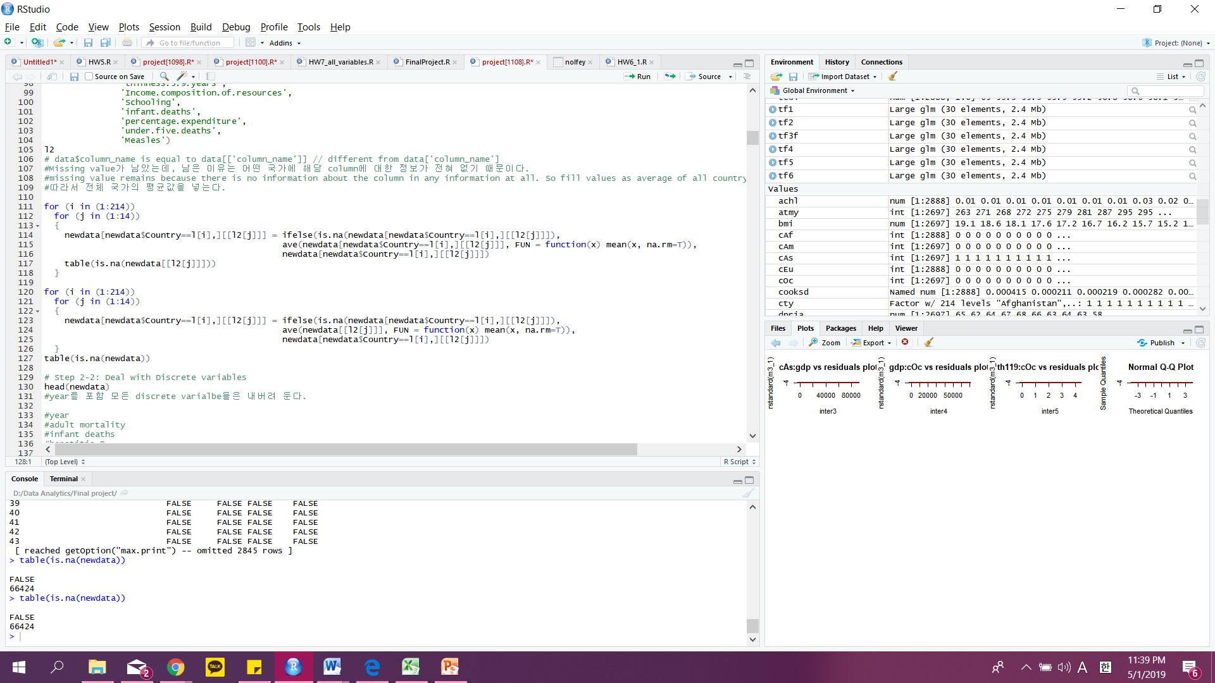



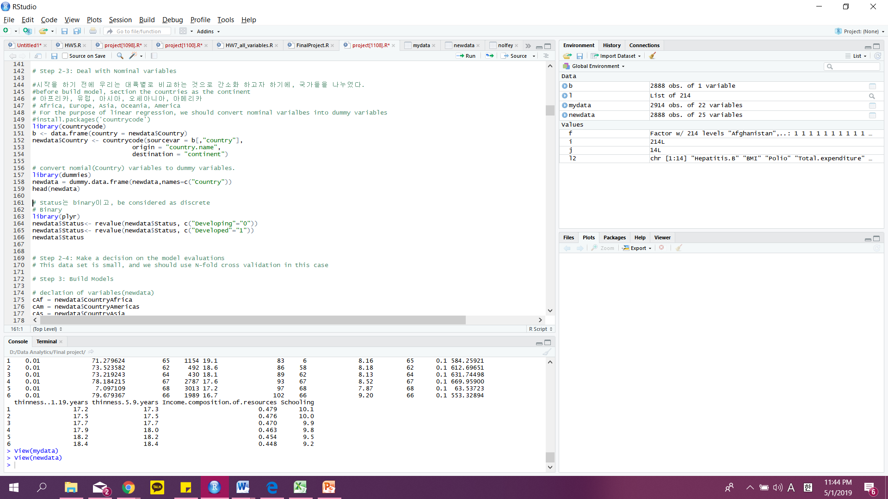





First of all, we examined linear relationship between X and Y variables via checking the correlation by transforming Y. Also, confirmed the transformed X variables which have a small correlation with Y.

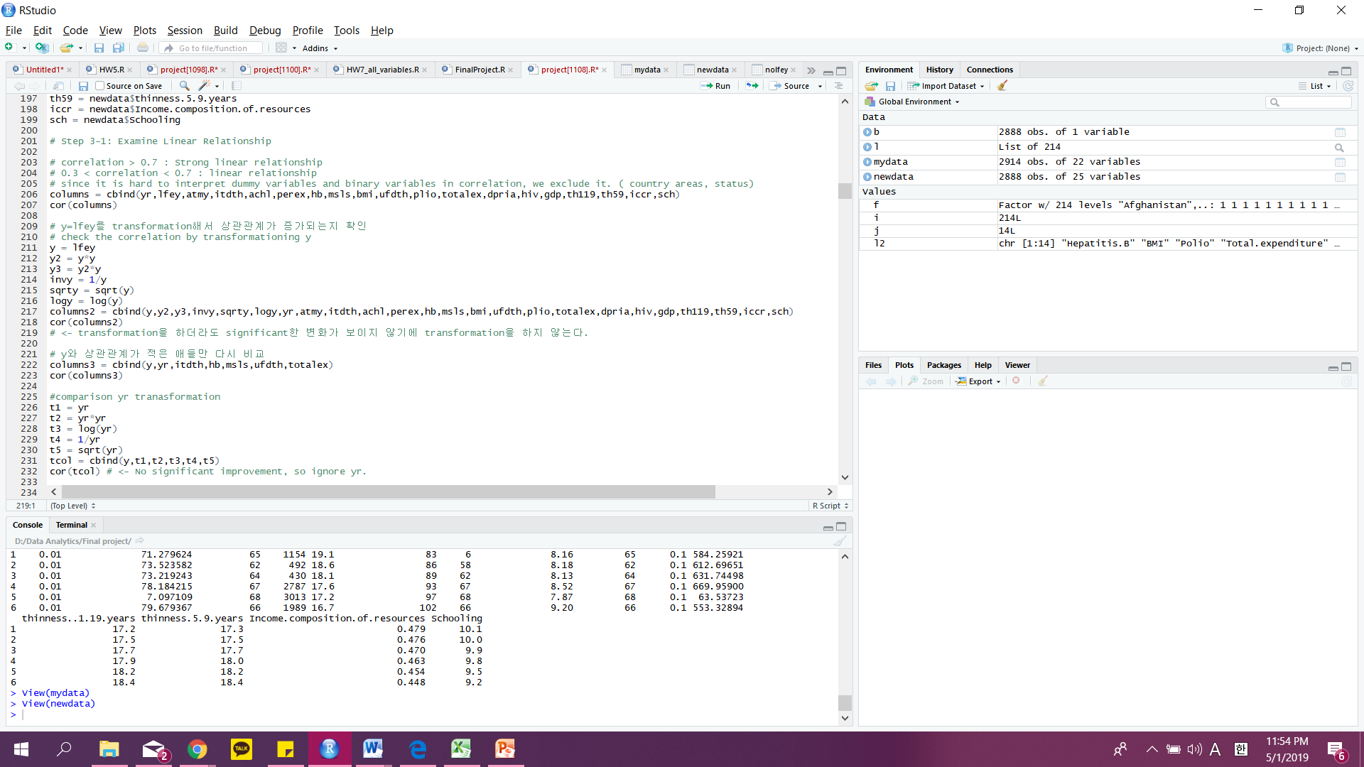

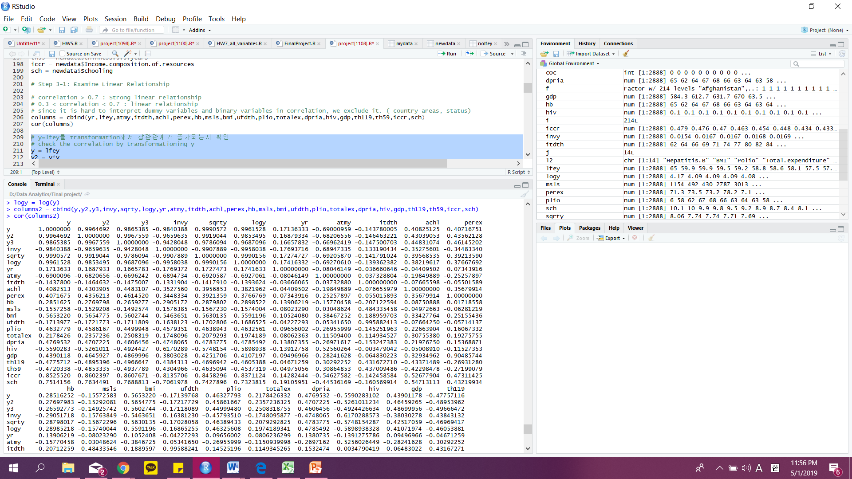

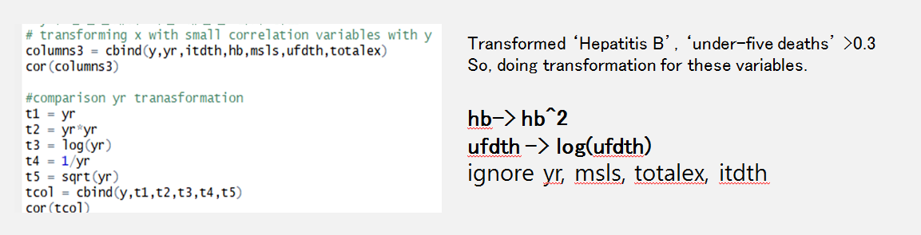

Second, built the models by feature selection. Tested the VIF to model. If the VIF test value is larger than 4, remove the value for building models. We performed feature selection methods through backward/forward/both stepwise function and best subset function.

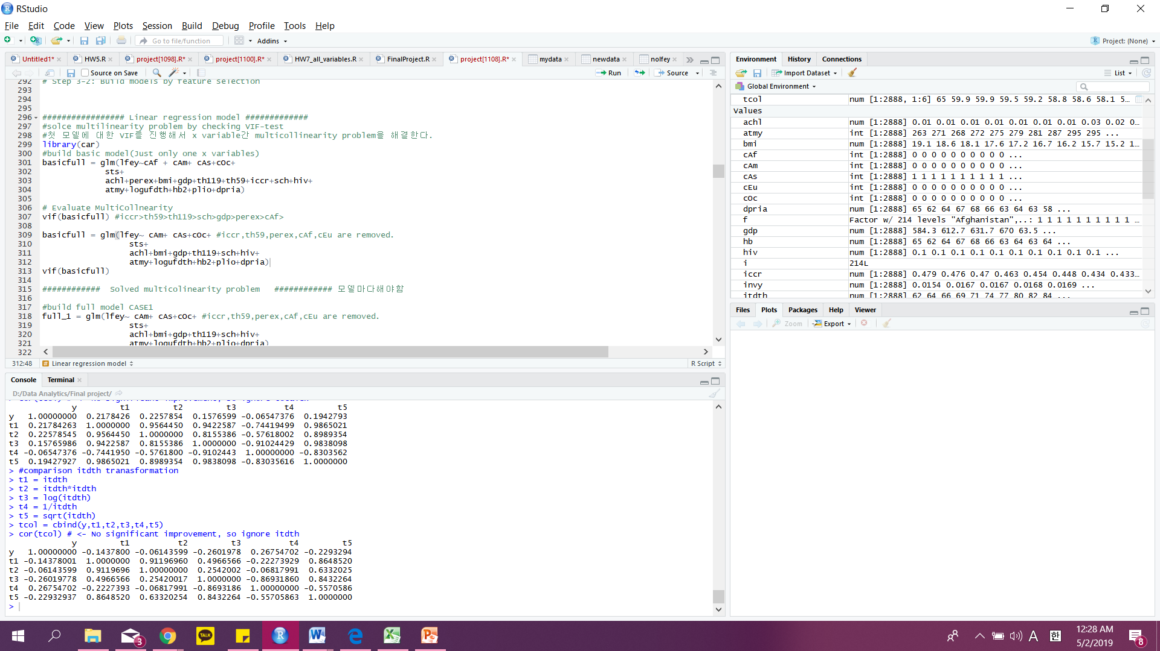

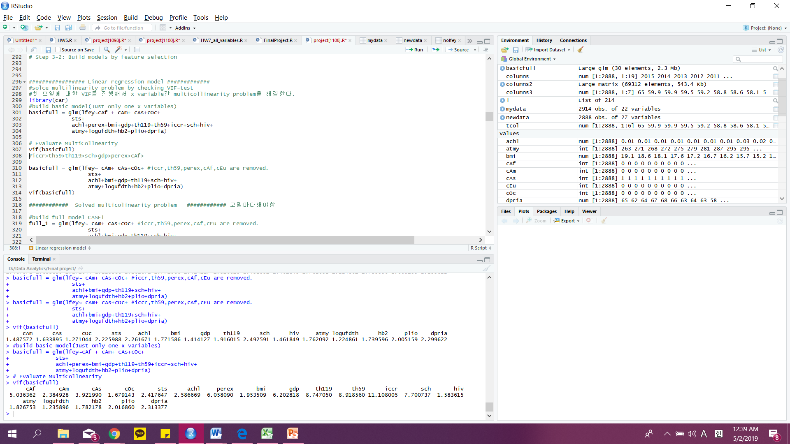

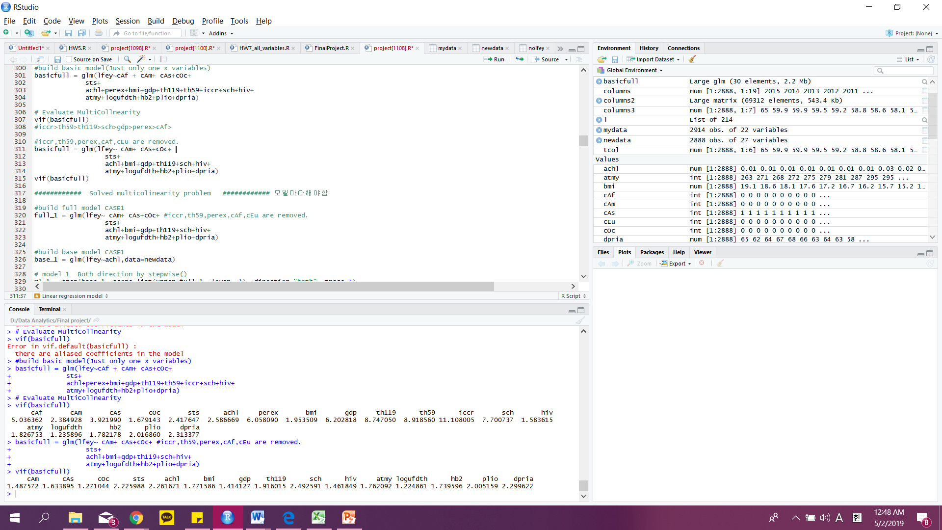

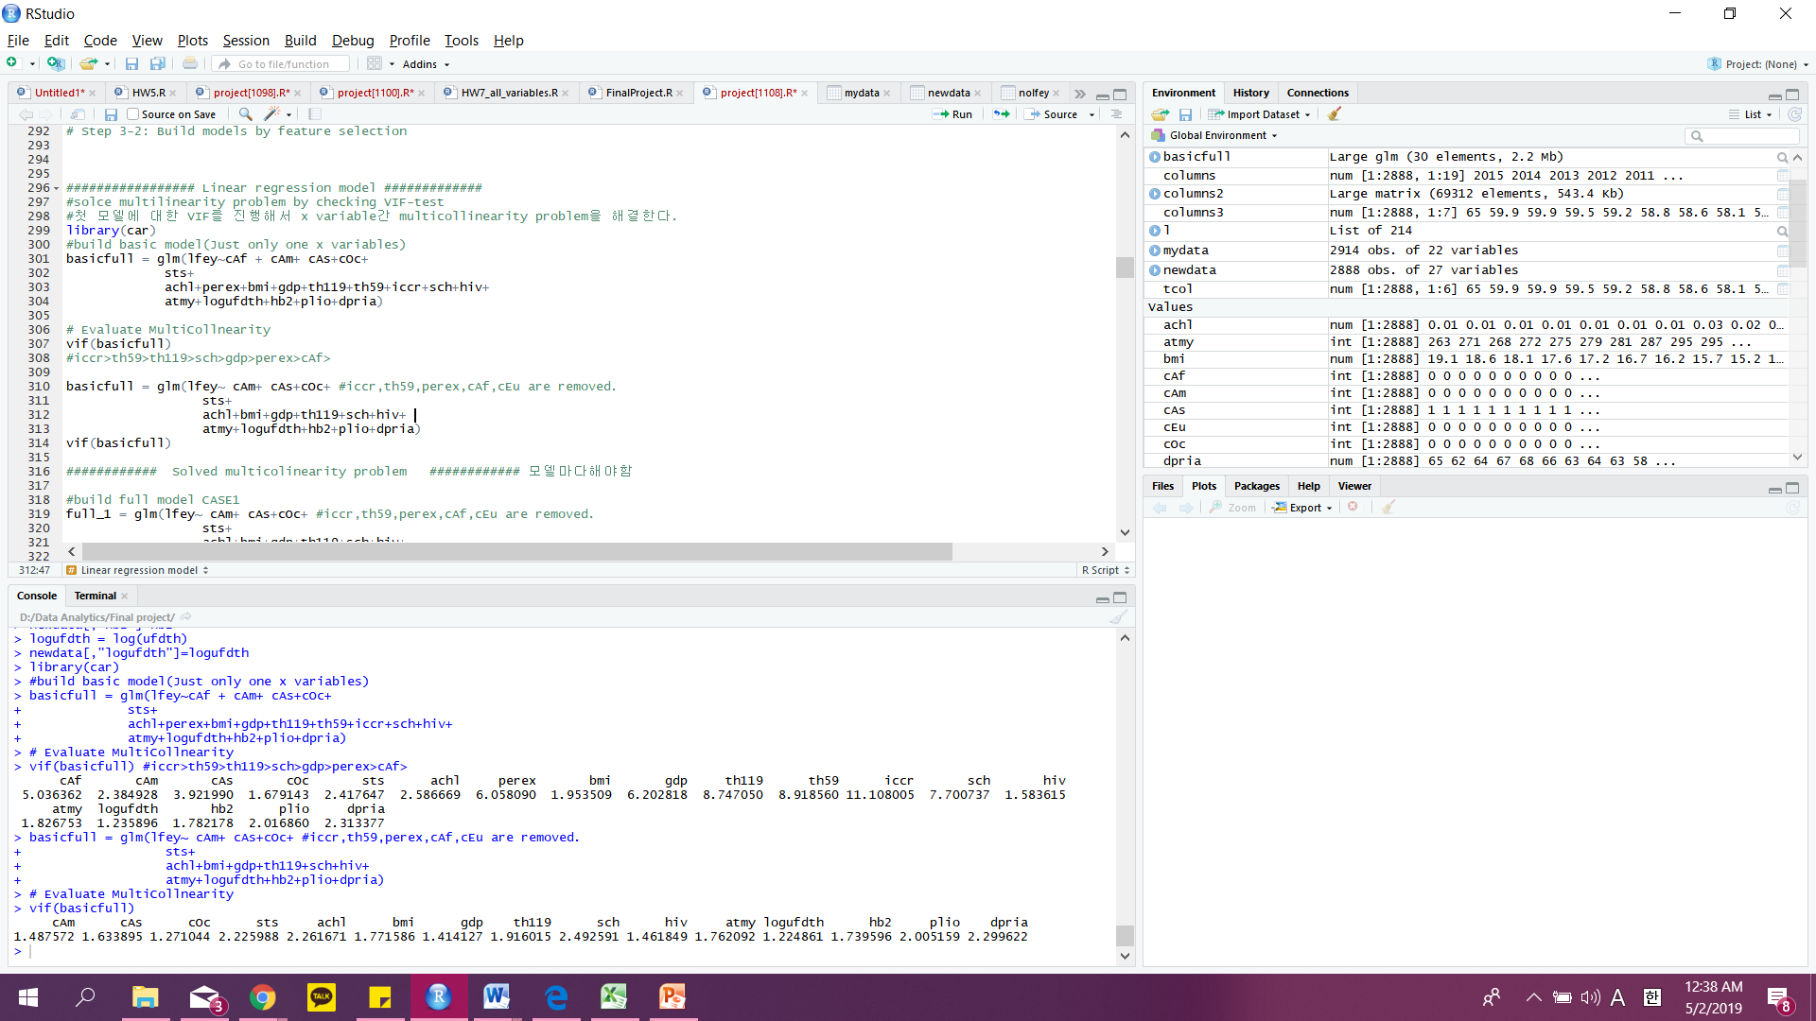

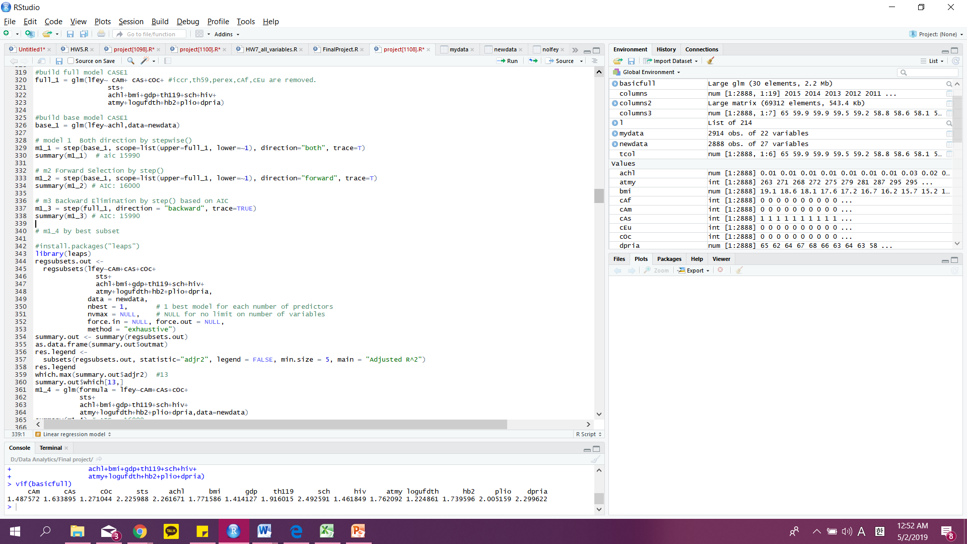





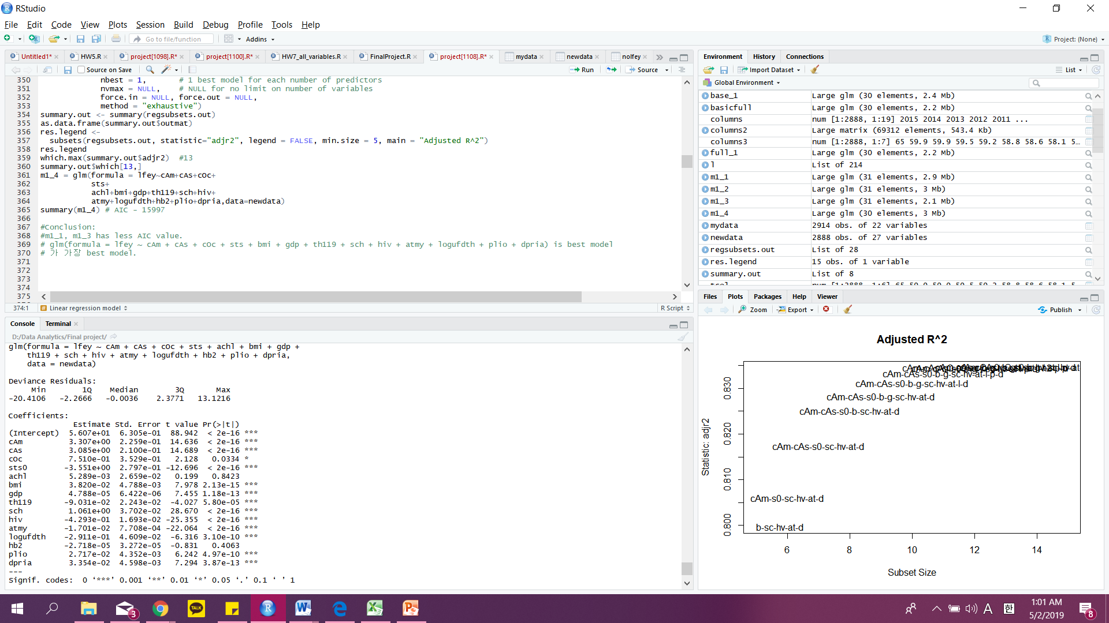

Third, we checked the polynomial and interaction term through each variable of the graph.

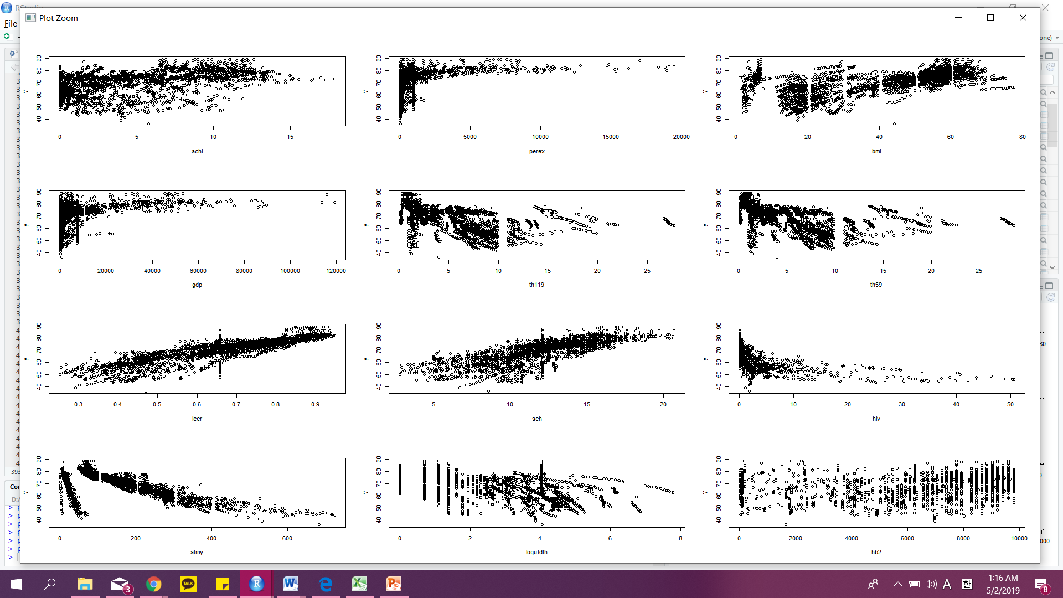

It is doubtful that these variables are polynomial.

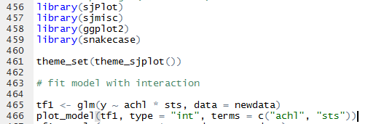

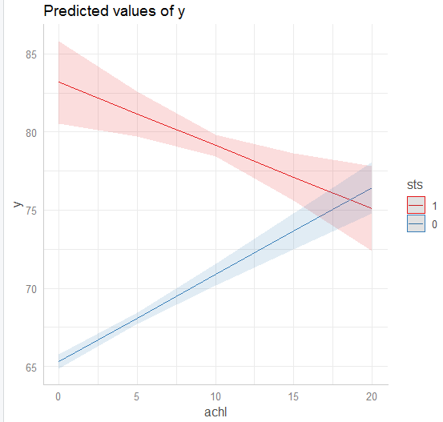 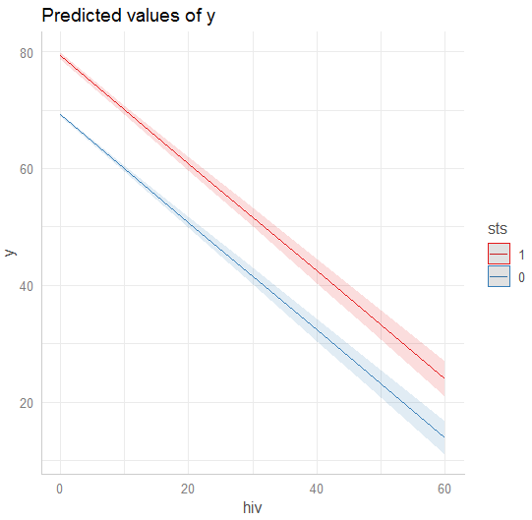

If slopes are different, it means there is interaction term between two x variables.

For the fourth, since data size is small we’ll use N-fold evaluation, so we don’t need to check F-test. We verified model is qualified or not. Constant variance, linearity relationship and distribution of residuals have been checked for validation.

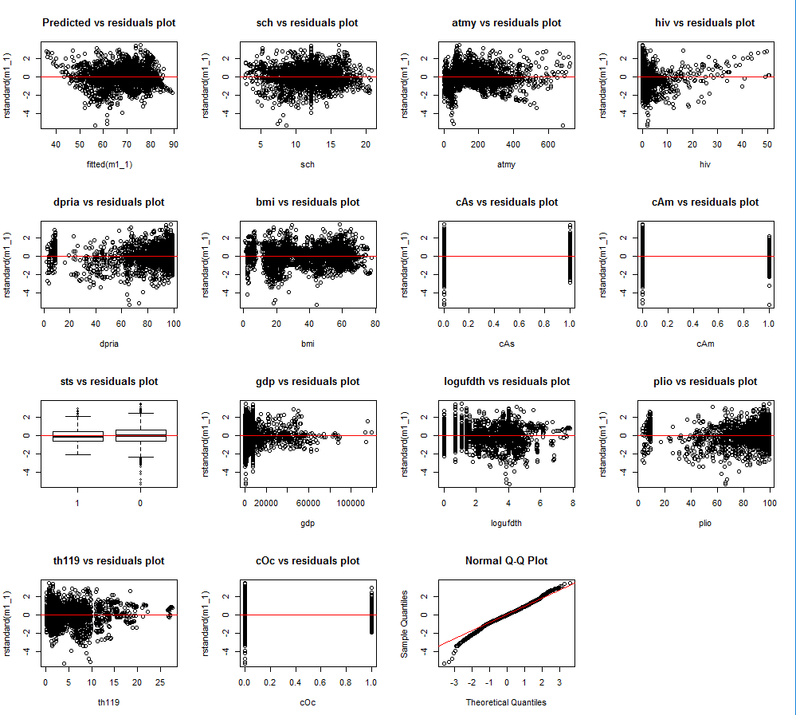

Finally, after performing residual analysis, we evaluated model by N-fold cross validations.

And for the accurate model, found the influential points and removed it.

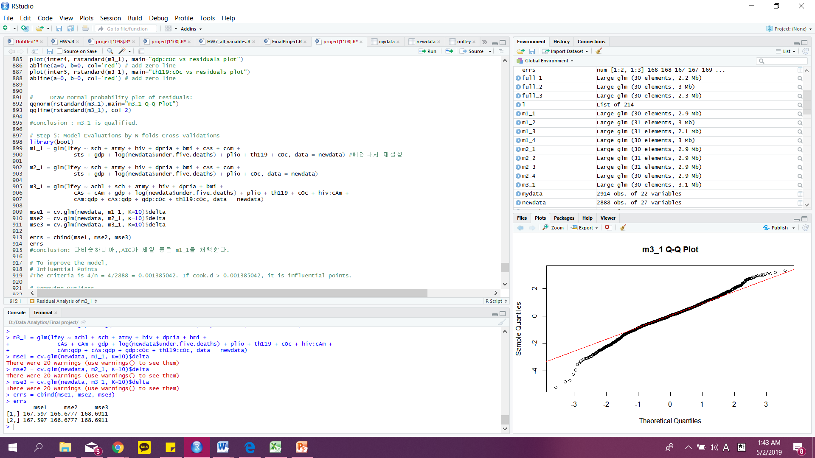



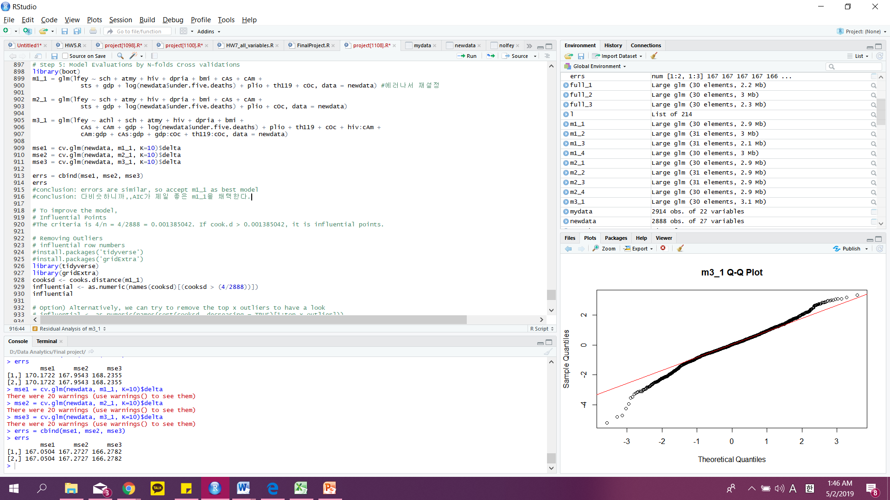

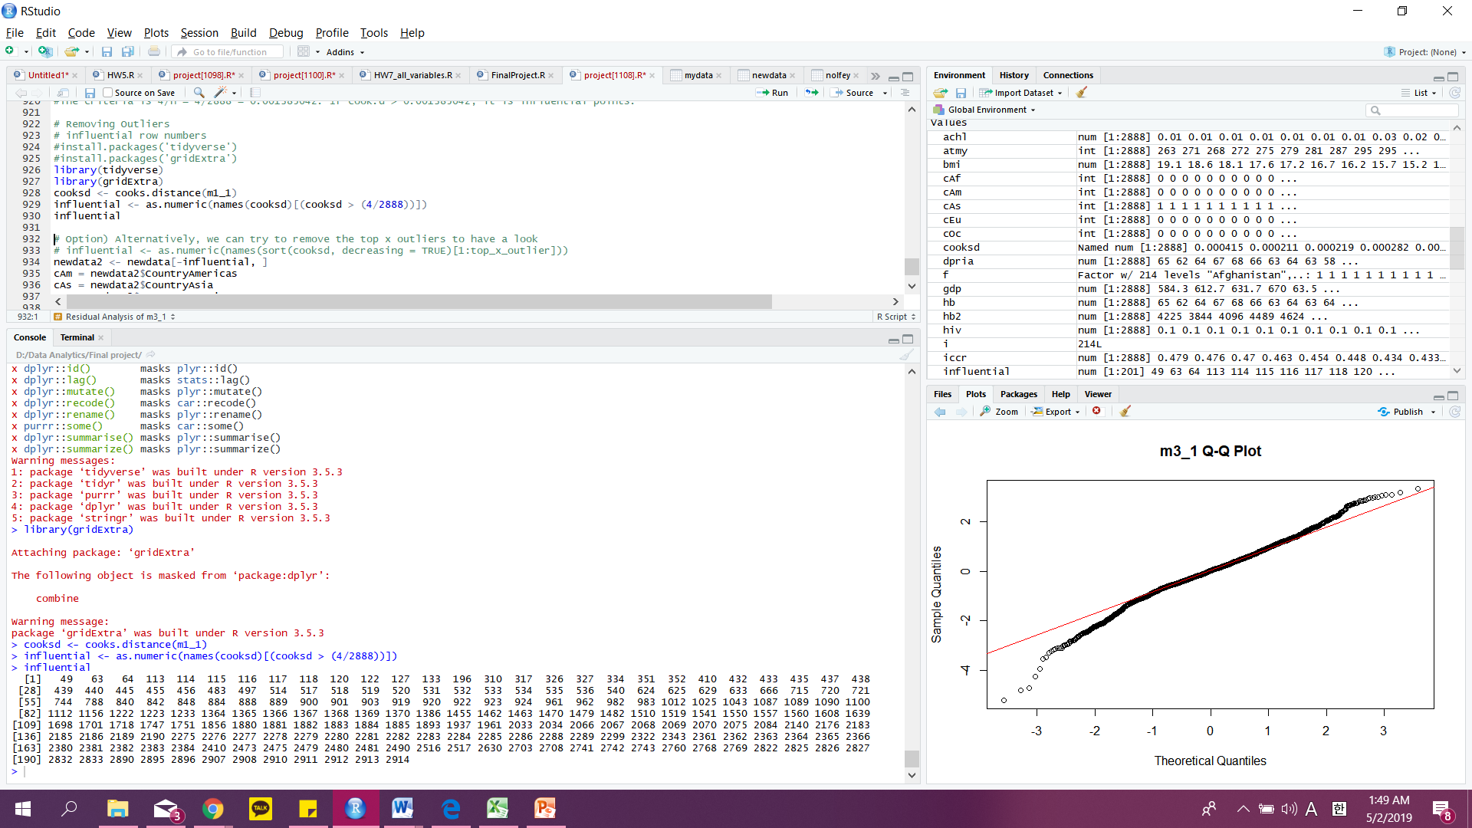



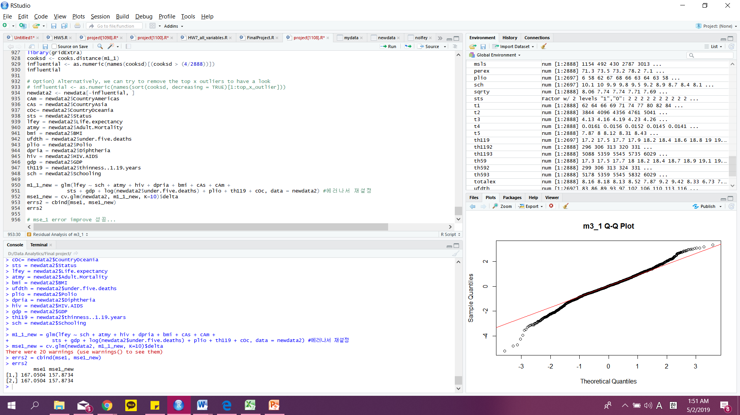



## 5.2. Evaluations and Results

Given a same problem, you may have several solutions or build several models

Evaluate your solutions based on selected metrics and compare them

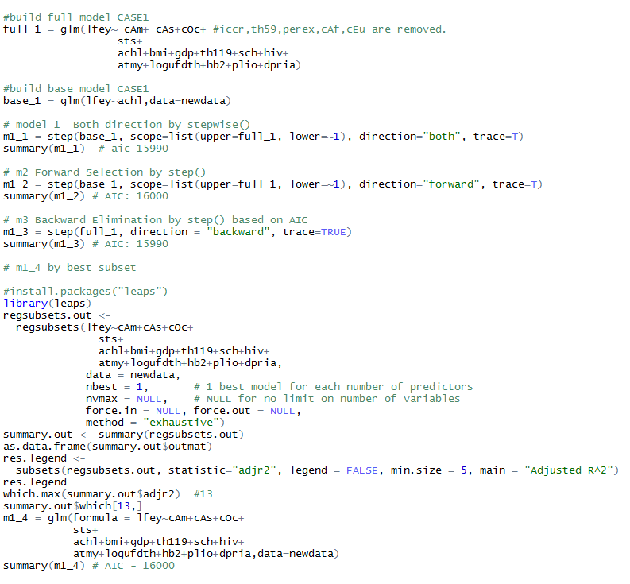



**These models above are from CASE1(Linear Regression)**

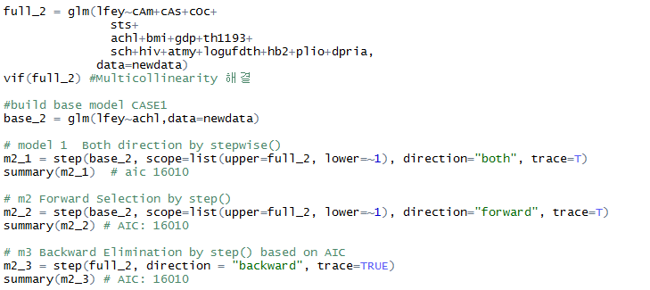

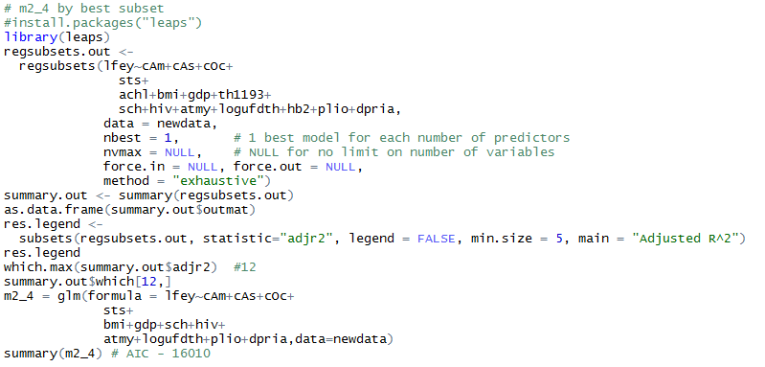



**These models above are from CASE2(Polynomial Regression)**

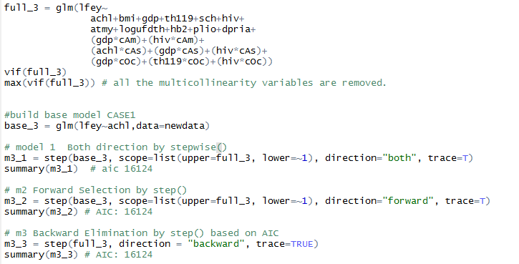

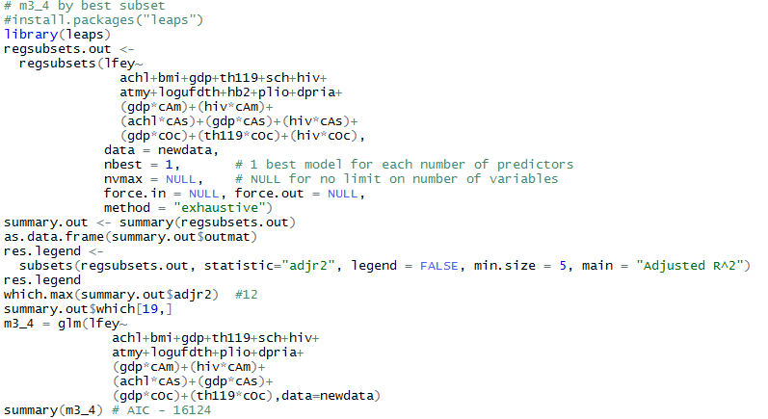



**These models above are from CASE3(Polynomial Regression + Interaction Term)**

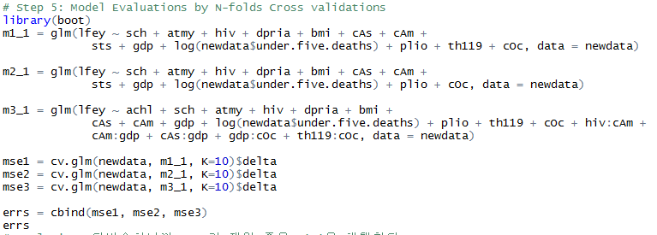

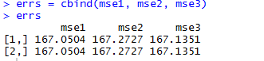



**So decided m1_1 is the best model in comparison with error of models**

## 5.3. Findings

From the above steps, we conclude that the optimal model is m1_1_new.

In conclusion, there is no polynomial variables or interaction term in the optimal model.

We were also able to improve the model by removing Influential Points.









Our conclusions will be addressed in the following steps.

# **6. Conclusions and Future Work**

## 6.1. Conclusions

A short summary of your whole project and conclusions, such as what you want to, why you want to do so, which solutions you use, and which findings or final results you get finally.

**Life Expectancy** = 5.746e+01+

(1.003e+00\***Schooling**)+(-1.844e-02\***Adult.Mortality**) + (-4.094e-01\***HIV.AIDS**) +

(3.460e-02\***Diphtheria**) + (3.565e-02\***BMI**)+ (-3.633e+00*(**Status**=0)) + (5.132e-05\***GDP**) +

(-2.801e-01*log(**Under.Five.Deaths**)) + (2.157e-02\***Polio**) + (-9.838e-02\***thinness..1.19.years**)

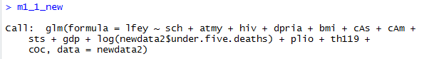

With respect to world data, the most significant factor in life expectancy is Schooling, Status. As the number of years of education increases, life expectancy also increases by about one year. It was also found that developing countries are about 3.6 years shorter than developed countries.

Therefore, in order to increase the life expectancy, it can be inferred that the development of education and the formation of infrastructure to become a developed country are very important.

## 6.2. Limitations

Our limitation is that we can see which x variable affects life expectancy, but it is difficult to interpret it in detail.

For example, we predicted that high BMI would lower life expectancy due to adult disease or other factors. However, the higher the BMI, the higher the life expectancy.

Therefore, it is difficult to interpret variable without background knowledge.

Secondly, because the data are based on world data, the variables may be different for each region and country. Therefore, I think that if we classified the data by region and proceeded, we would have got a more reliable expression.

## 6.3. Potential Improvements or Future Work

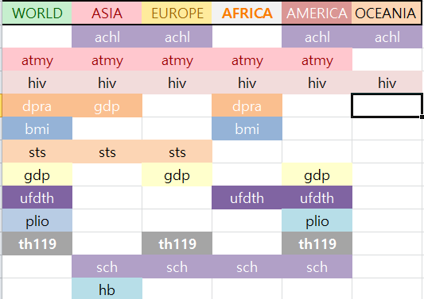

The table above is a table summarizing the variables affecting the y variable after dividing the world and the world into five categories and proceeding with linear regression.

As mentioned in limitations, if we predict linear regression based on world, environment, disease importance and mortality rate are different in each region. Therefore, if you want to obtain information to increase your life expectancy from a world-based linear regression, this will be unreliable.

Therefore, if you make a prediction by making a linear regression for each region or country, you will get much more reliable information.